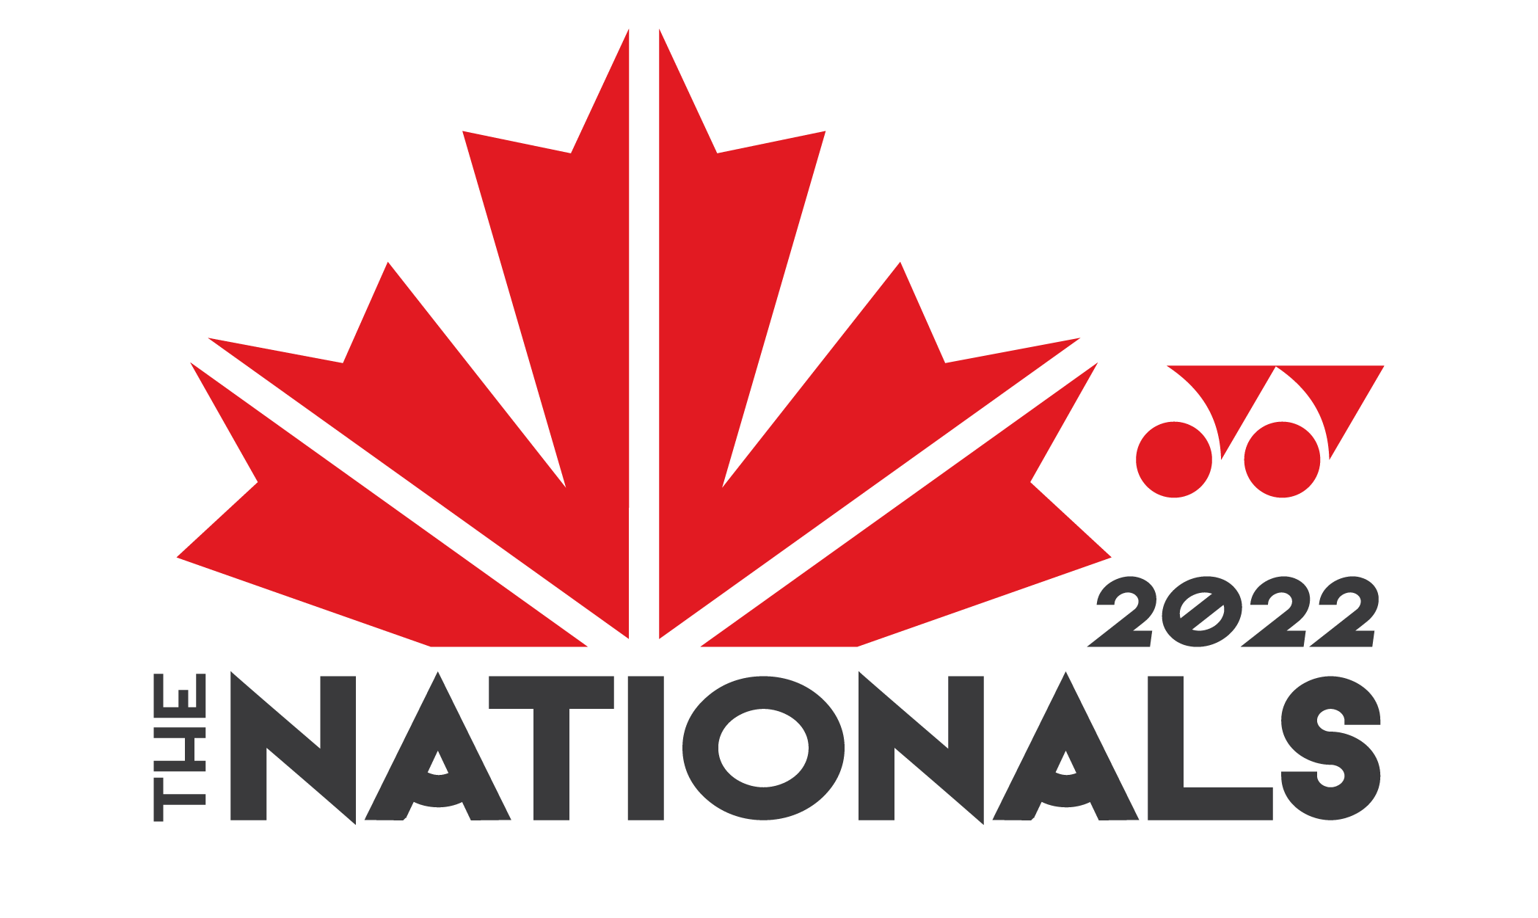
Sponsor Event Hotel Wristband Registration Form

Please fill out this registration form if you are staying in one of the official host hotel blocks. This form will be exchanged for your wristbands. Must be provided at the ticket office upon entry.
Wristbands will only be provided once, in the event that your wristband is damaged please visit the ticket office with the wristband on to be issued a new one. Lost or stolen wristbands will not be replaced.
List all guests staying in your room. It is not possible to list more people than the reservation is for.
Guests (Please print): |  | Adult | Youth
1._________________________________________ |  | ____ | ____
2._________________________________________ |  | ____ | ____
3._________________________________________ |  | ____ | ____
4._________________________________________ |  | ____ | ____

Check-In Date: ______________ | Check-Out Date: ____________________
Total # of Nights: _____________ | Hotel Name: ________________________

I have received _____________ wristbands at check-in. I accept the policies in regards to admission and accessing 2022 YONEX NATIONAL BADMINTON CHAMPIONSHIPS and understand that losing these wristbands will incur replacement fee charges.

Signed upon delivery
Hotel Guest:

__________________ __________________ ____________________ _________________ Print Name: Sign Name: Home Province: Date:

Administrative Staff:

__________________ __________________ Print Name: Sign Name:
June 2022

Dear Guests:

All guests (coaches and athletes included) will require special event wristbands to access the competition venue of the 2022 Yonex National Badminton Championships. These wristbands are available for an additional fee at the ticket office.

The admission fee will be waived for persons registered in the official hotel block at either one of our two host hotels. Wristbands will be issued relative to the number of people booked in the room and the number of days booked. Guests staying at a host hotel but not booked in the block will not be entitled to receive complimentary wristbands so please review your booking.

The admission fee will also be waived for anyone who presents a government-issued I.D. from an approved Canadian postal code within the geographical boundaries of Strathcona County or Edmonton.

Admission fees are as follows:

11 years of age or younger Free
Single day admission $20
4-day admission $40
8-day admission $60

The Yonex National Badminton Championships earns sponsorships through contracted room bookings, which is the reason why reservations must be made through a block system. Despite being inconvenient, the wristband system is the best way to ensure that the organizing committee can meet its financial needs and keep The Nationals running in the future. Using a block system also helps to keep room rates low, especially during holidays. It isn’t enough just to book with the hotel outside of our block as there is no way to distinguish guests who are attending The Nationals and those who are booking for other reasons.

Wristband system details:

- Guests of the event booked within the official room block at a designated hotel will submit a completed Wristband Registration Form at check-in, and will receive an appropriate number of wristbands.

- Wristbands will be issued only once and they will be multi-coloured.

- Wristbands cannot be removed without being destroyed. Guests who lose their wristbands or apply the wrong ones will have to purchase replacements at ticket office.

Please note: Wristbands are required to access the competition and viewing area.

